Pet Alert
Documentation project

Client Android
Android Client apk
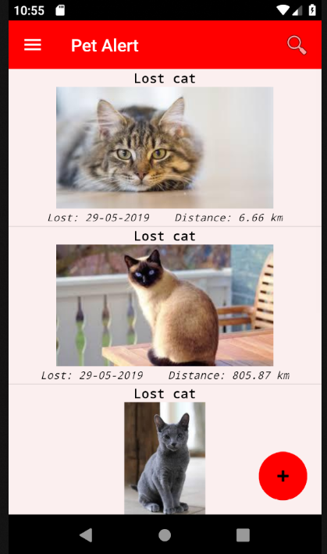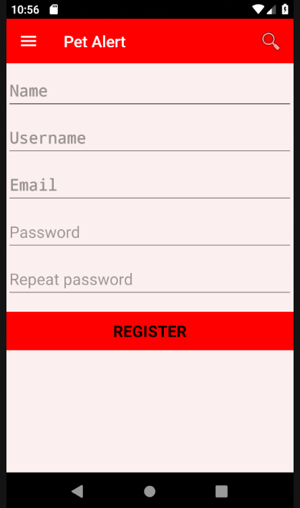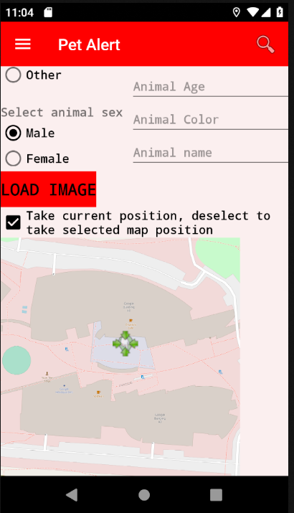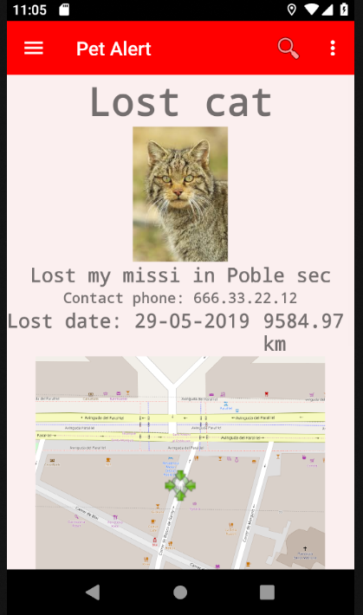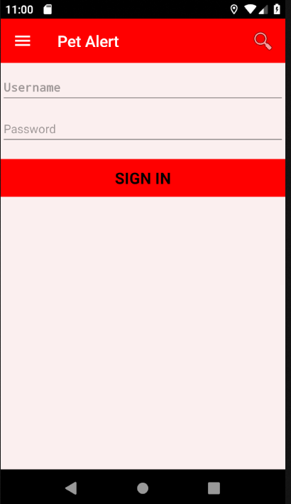

Non-Functional Requirements
The application will run in an Android based system with an API between 23 and 28 maximum.
Login/Register
A MySQL database will be used in an Ubuntu Server which will keep the user data, alerts, messages, etc.
Alert management
The alerts will be kept in a MySQL database.
The alerts will be found according to specified filtered parameters as distance or kind of animal.
The GPS of the mobile device will be used to locate where the alert is created.
Alert data collection from a web service.
Inadequate alert report button, which will be notified to the system administrator.
Layouts
Application form layout which allows to add new alerts.
Application form layout which allows to modify already existing alerts.
Setting and main window layouts.
Notifications
A distance range will be set to receive the alerts.
Notification type selection: the user wants to receive mobile notification alerts or via e-mail.
Notifications will be enabled or disabled.
Messenger service
Internal messenger service system of the application with alert through notification.

E/R Diagram


